CS570_HW3-1-Huijuan Xie-19893

**MapReduce on Ubuntu**

**Hadoop Installation on Google Cloud Platform (GCP) Compute Engine** Note: This document is mainly about “Hadoop: Setting up a Single Node Cluster”. Reference Link: [Apache Hadoop 3.3.4 – Hadoop: Setting up a Single Node Cluster.](https://hadoop.apache.org/docs/stable/hadoop-project-dist/hadoop-common/SingleCluster.html)

|  |
| --- |
|  |
|  |  |

Create a VM instances, set the setting

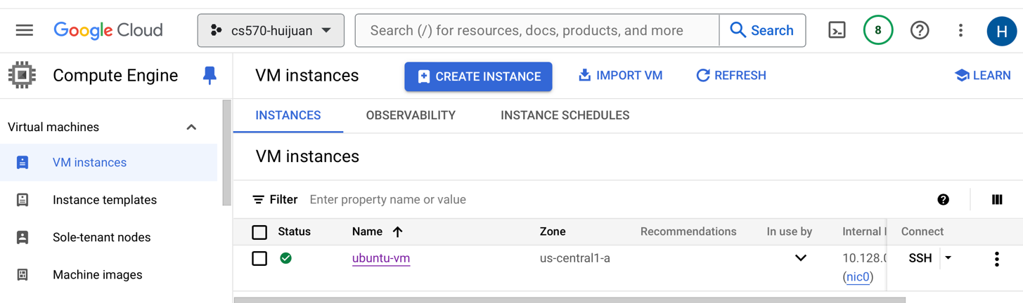

2> Login in ubuntu VM to install Hadoop including requisite software step by step

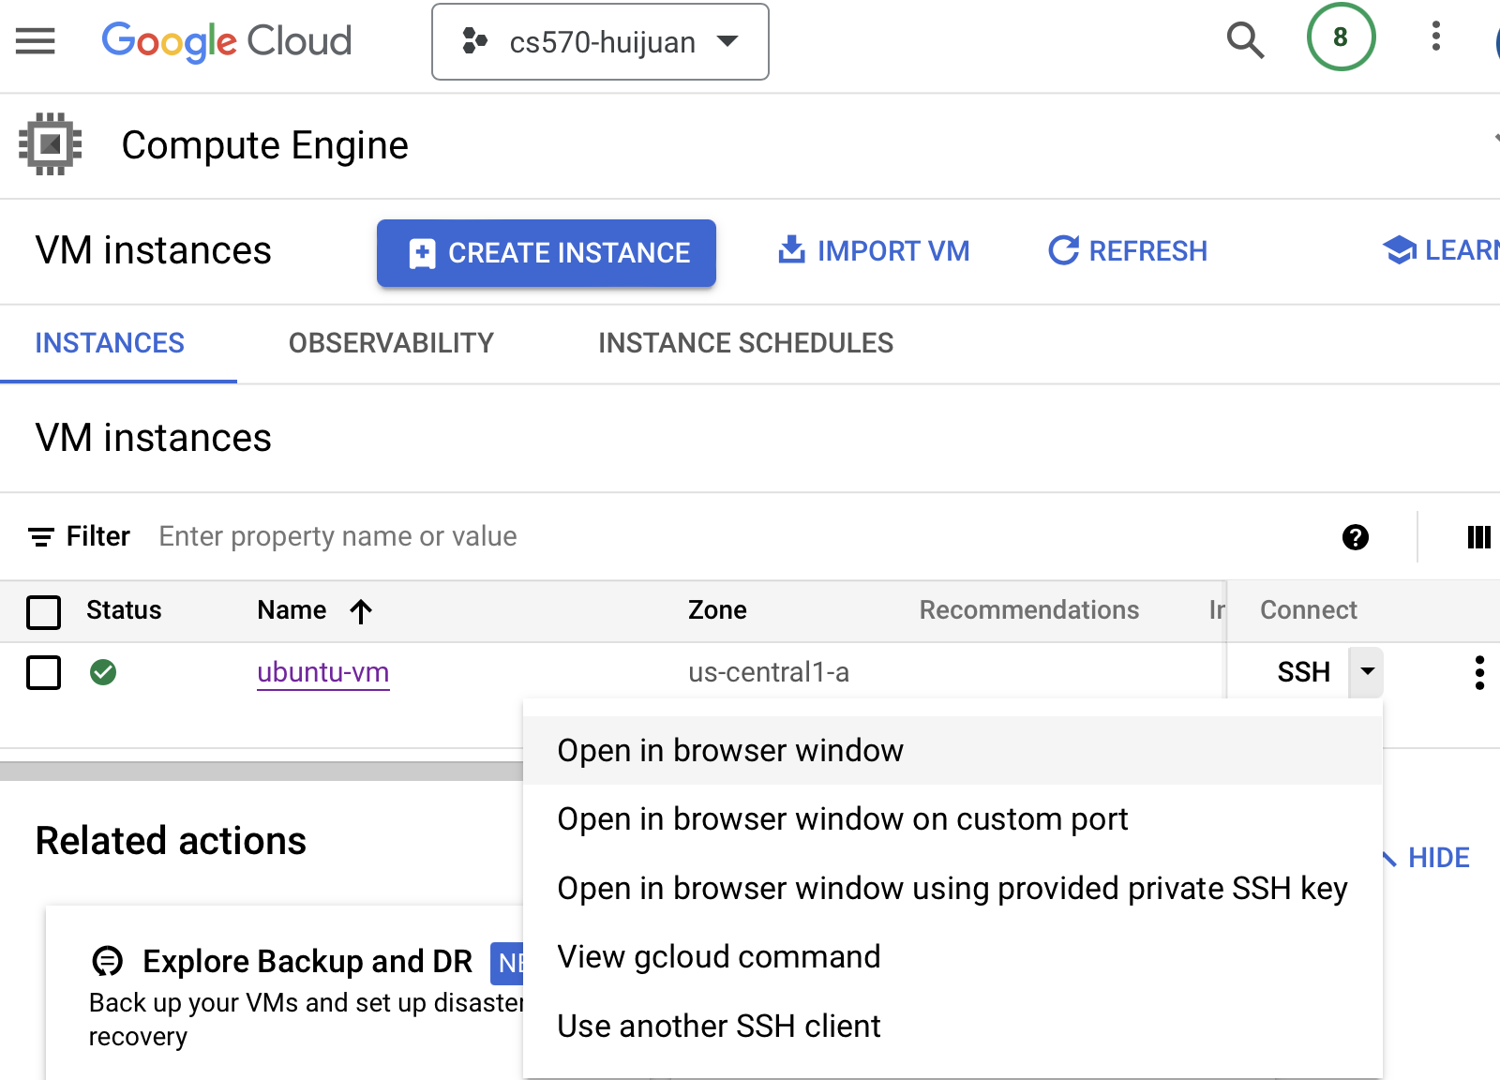

Install java 8:

$ sudo apt-get update

$ sudo apt-get install openjdk-8-jdk

$ java -version

This command will display the java version info if installation is successful

$ sudo update-alternatives –config java

To know the java path, write down this path for later path setting

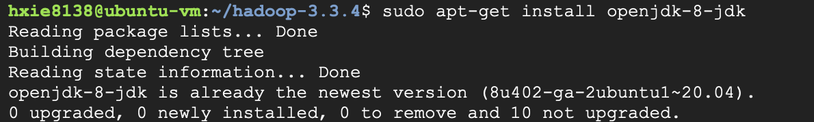

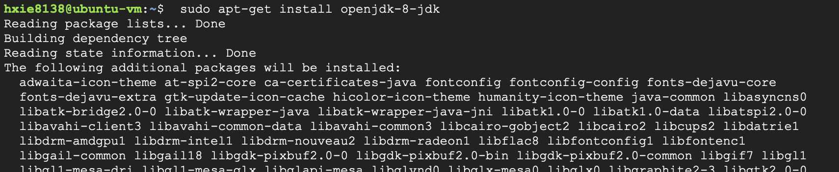

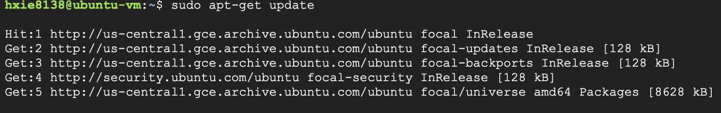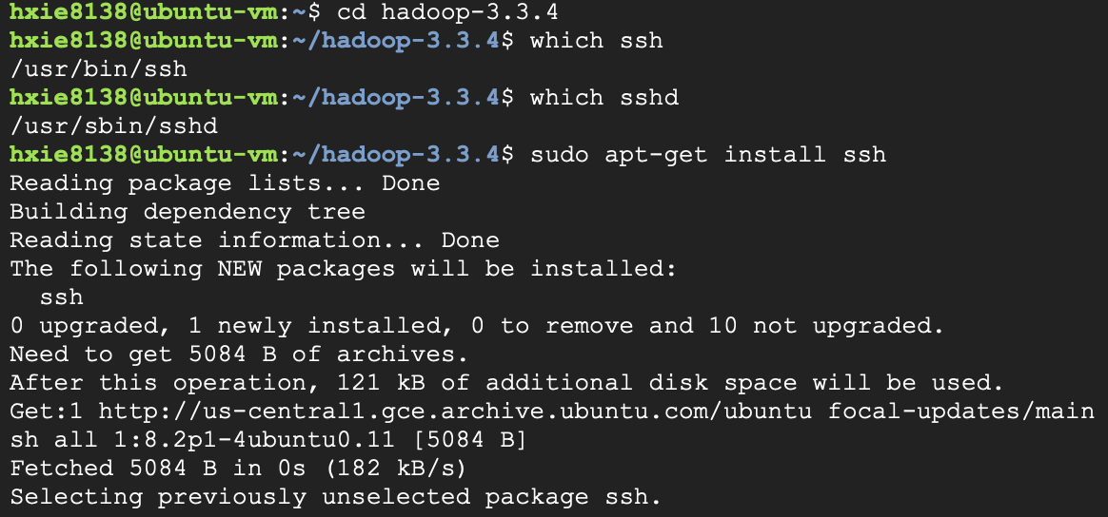

Download Hadoop 3.3.4, and unpack them.

$ wget <https://dlcdn.apache.org/hadoop/common/hadoop-3.3.4/hadoop-3.3.4.tar.gz>

$ tar xvzf hadoop-3.3.4.tar.gz

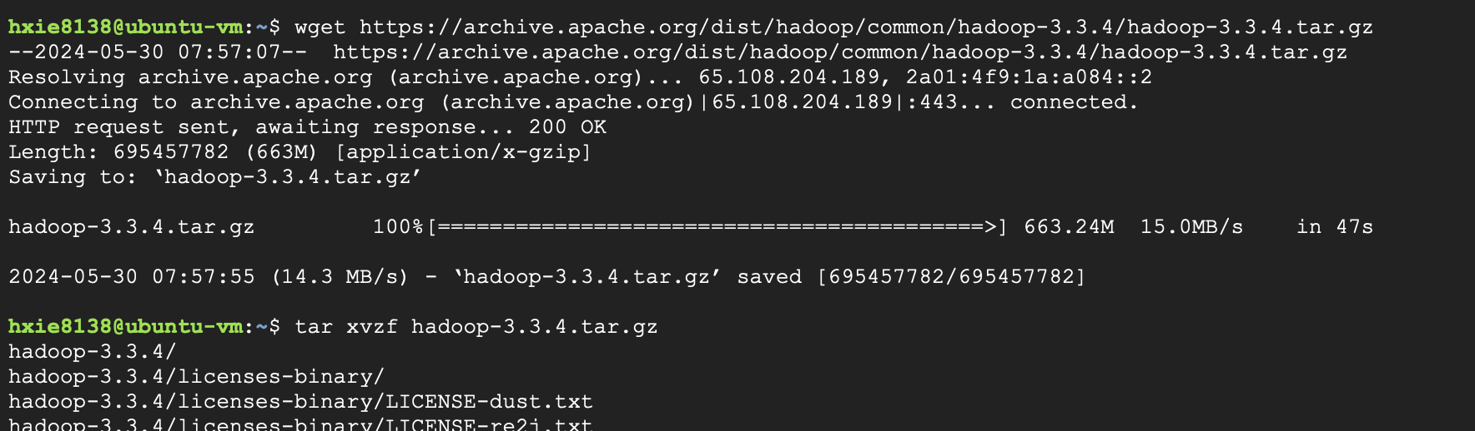

Set java path for Hadoop:

$ cd hadoop-3.3.4/

$ vi etc/Hadoop/hadoop-env.sh

Add “ export JAVA_HOME=/usr/lib/jvm/java-8-openjdk-amd64/jre/bin/java”

Set other path/variables for Hadoop

$ vi ~/.bashrc

Add the following lines:

export JAVA_HOME=/usr/lib/jvm/java-8-openjdk-amd64/jre/bin/java export PDSH_RCMD_TYPE=ssh

export PATH=${JAVA_HOME}/bin:${PATH}

export HADOOP_CLASSPATH=${JAVA_HOME}/lib/tools.jar

$ source ~/.bashrc

Test the Hadoop command:

$ bin/Hadoop

This will display the usage documentation for the Hadoop script if Hadoop is installed successfully.

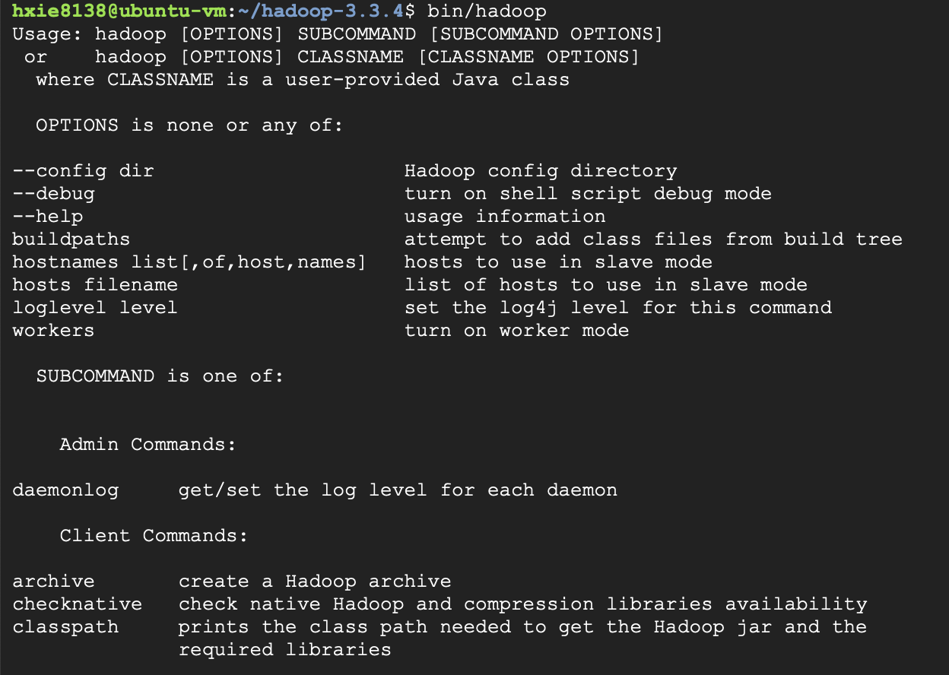

Now, we could run some test examples in different operations according to this link [Apache](https://hadoop.apache.org/docs/stable/hadoop-project-dist/hadoop-common/SingleCluster.html) [Hadoop 3.3.4 – Hadoop: Setting up a Single Node Cluster.](https://hadoop.apache.org/docs/stable/hadoop-project-dist/hadoop-common/SingleCluster.html)

3> Standalone Operation

By default, Hadoop is configured to run in a non-distributed mode, as a single Java process. This is useful for debugging.

The following example copies the unpacked conf directory to use as input and then finds and displays every match of the given regular expression. Output is written to the given output directory.

$ mkdir input

$ cp etc/hadoop/*.xml input

$ bin/hadoop jar share/hadoop/mapreduce/hadoop-mapreduce-examples-3.3.4.jar grep input output 'dfs[a-z.]+'

$ cat output/*

|  |
| --- |
|  |
|  |  |

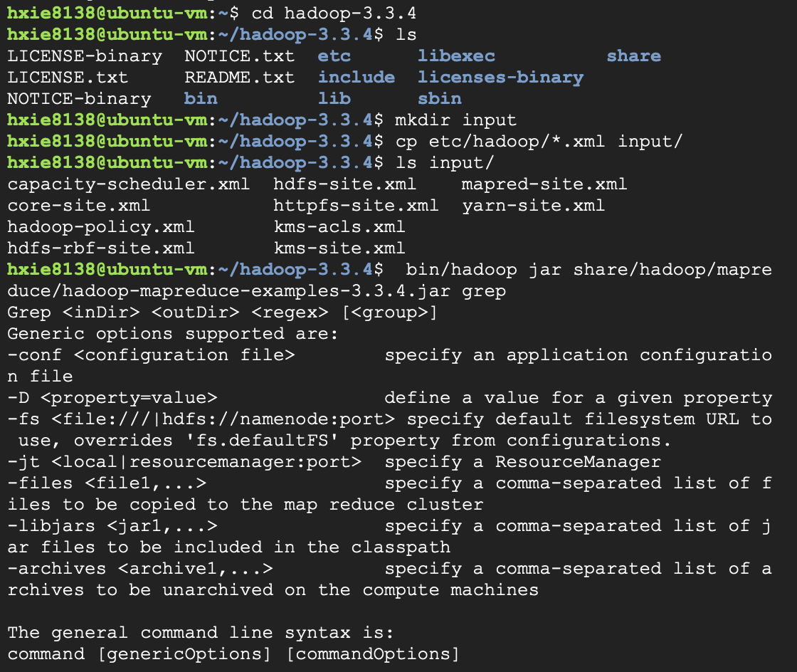

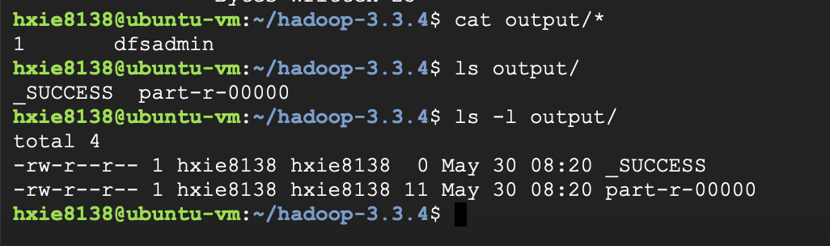



4> Pseudo-Distributed Operation

Hadoop can also be run on a single-node in a pseudo-distributed mode where each Hadoop daemon runs in a separate Java process.

Configure parameters:

$ vi etc/hadoop/core-site.xml

$ vi etc/hadoop/hdfs-site.xml

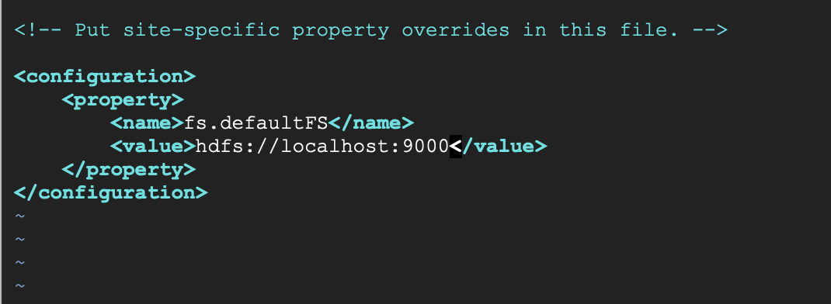

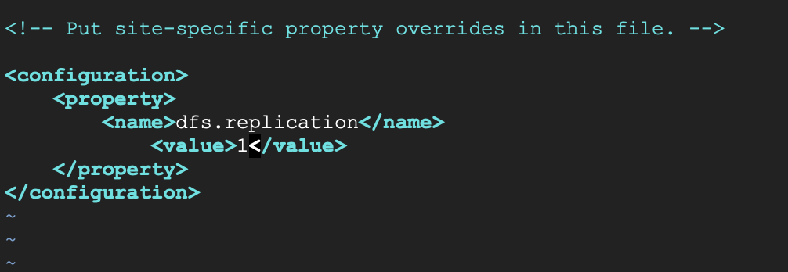

ssh passphraseless setting:

$ ssh-keygen -t rsa -P '' -f ~/.ssh/id_rsa

$ cat ~/.ssh/id_rsa.pub >> ~/.ssh/authorized_keys

$ chmod 0600 ~/.ssh/authorized_keys $ ssh-keygen -t rsa -P '' -f ~/.ssh/id_rsa

$ ssh localhost

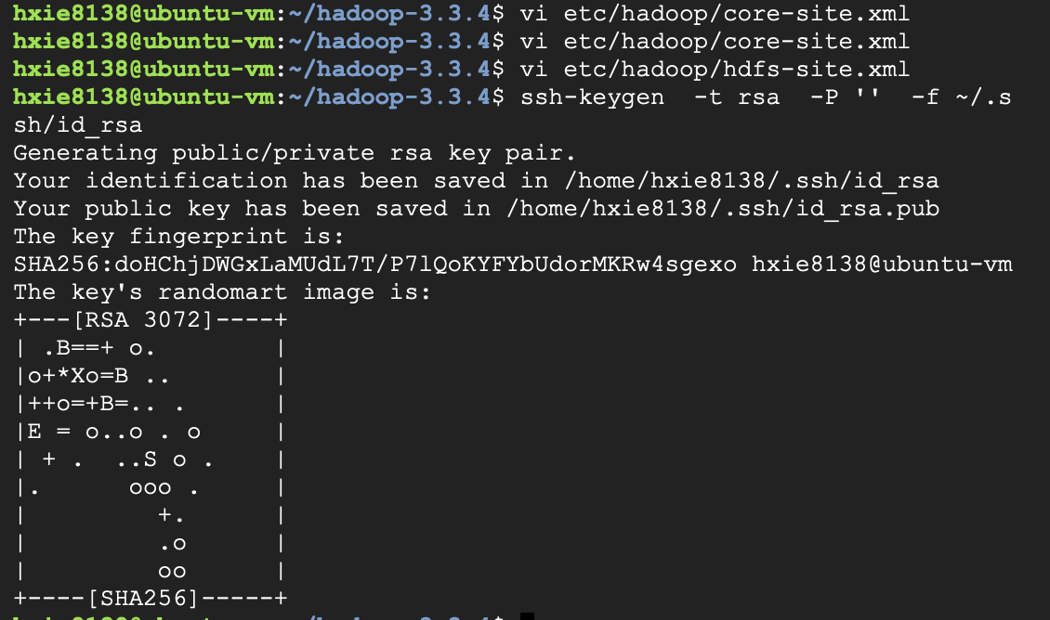

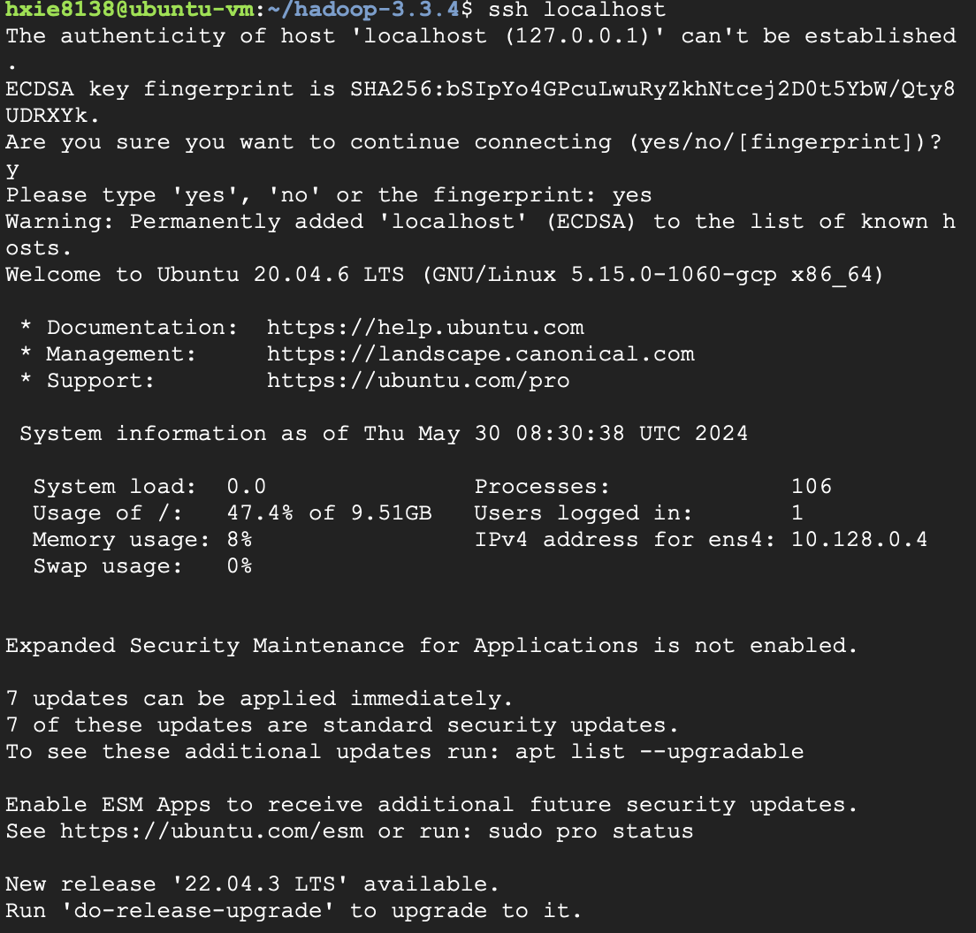

The following instructions are to run a MapReduce job locally.

* 1. Format file system

$ bin/hdfs namenode -format

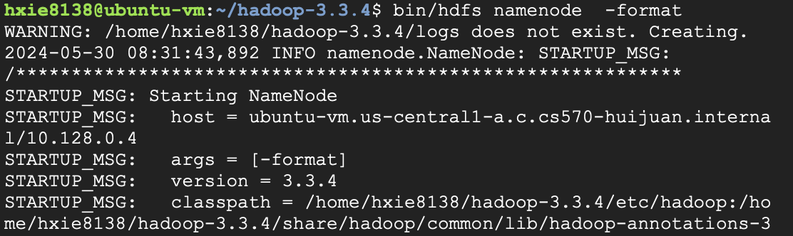

* 1. Start NameNode and DataNode daemon:

$ sbin/start-dfs.sh

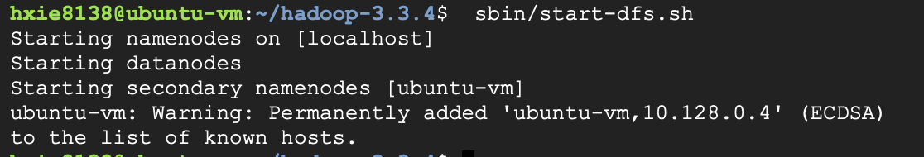

* 1. Make the HDFS directories required to execute MapReduce jobs:

# Note: We cannot create username randomly, we must use the username with which we login the this Linux server, e.g. cindy is not accepted at my first try, then I had to use xwu in my case.

**Create input files and run the mapreduce examples:**

# $ bin/hdfs dfs -mkdir /user

**$ bin/hdfs dfs -mkdir /user/<username>**

# $ bin/hdfs dfs -mkdir input

**$ bin/hdfs dfs -put etc/hadoop/*.xml input**

# $ bin/hadoop jar share/hadoop/mapreduce/hadoop-mapreduce-examples-3.3.4.jar grep input output 'dfs[a-z.]+'

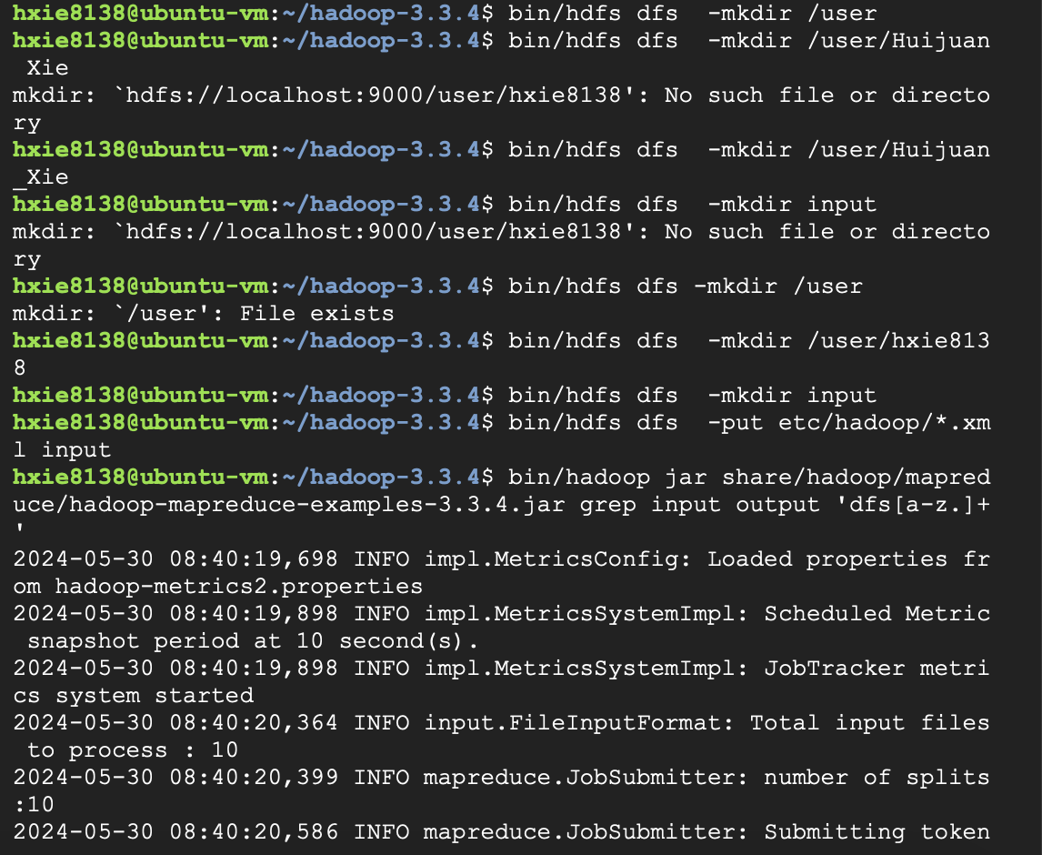

Copy and display the output files

$ bin/hdfs dfs -get output output

$ cat output/*

If you want to stop here, before you leave, you’d better stop the daemons, otherwise, skip this step.

$ sbin/stop-dfs.sh

Yarn on a Single Node

You can run a MapReduce job on YARN in a pseudo-distributed mode by setting a few parameters and running ResourceManager daemon and NodeManager daemon in addition.

1. Configure parameters as shown

$ vi etc/hadoop/mapred-site.xml

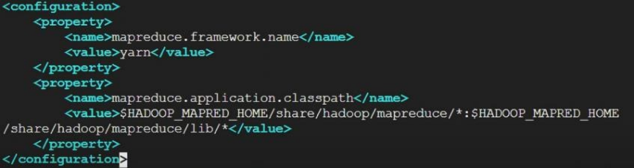

$ vi etc/Hadoop/yarn-site.xml

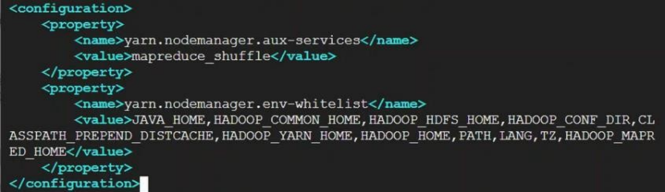

1. Start ResourceManager daemon and NodeManager daemon

$ sbin/start-yarn.sh

|  |
| --- |
|  |
|  |  |

1. Browser the web interface – It’s available at prot 8088, URL like this: http://localhost:8088/

Here, we use http://35.226.63.64:8088/ for GCP Hadoop environment in my case.

|  |
| --- |
|  |
|  |  |

1. Run a MapReduce case.

WordCount Example ( Reference link: [Apache Hadoop 3.3.4 – MapReduce Tutorial](https://hadoop.apache.org/docs/stable/hadoop-mapreduce-client/hadoop-mapreduce-client-core/MapReduceTutorial.html#Prerequisites) )

1> Create Java source code for WordCount. (Source codes are copied from the above link)

$ vi WordCount.java

2> Compile java code and create a jar

$ $ bin/hadoop com.sun.tools.javac.Main WordCount.java

$ jar cf wc.jar WordCount*.class

|  |
| --- |
|  |
|  |  |

3> Create hdfs directories, file01 and file02

$ bin/hadoop fs -ls /user/xwu/wordcount/input/

$ bin/hadoop fs -cat /user/xwu/wordcount/input/file01

è Hello World Bye World

$ bin/hadoop fs -cat /user/xwu/wordcount/input/file02

è Hello Hadoop Goodbye Hadoop

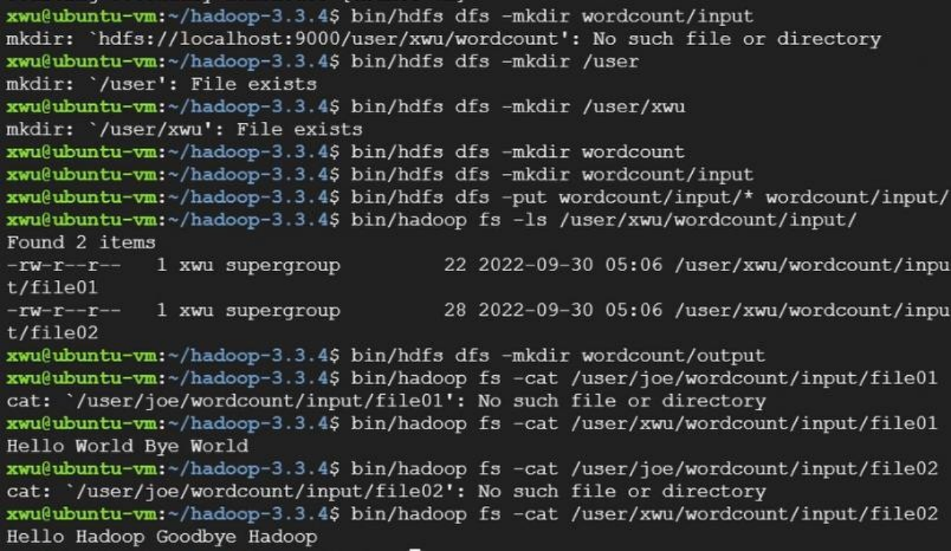

4> Run the application

$ bin/hadoop jar wc.jar WordCount /user/xwu/wordcount/input

/user/xwu/wordcount/output

|  |
| --- |
|  |
|  |  |

……

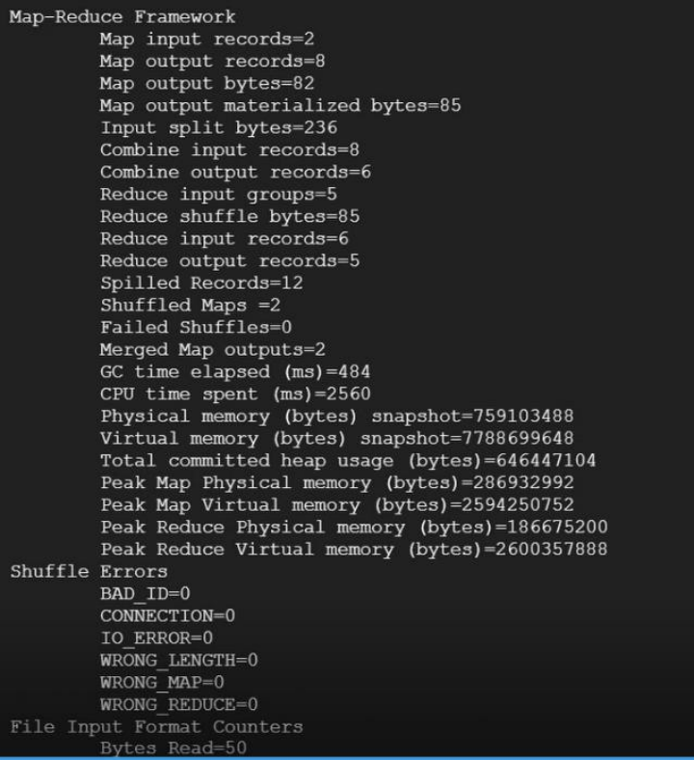

……

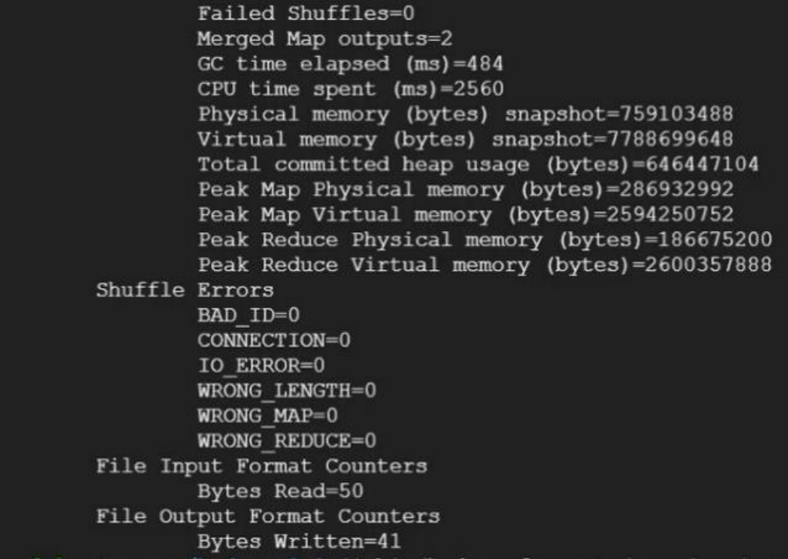

……

5> Display the output

$ bin/hadoop fs -cat /user/joe/wordcount/output/part-r-00000

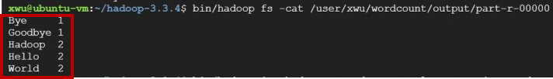

1. Stop the daemons.

$ sbin/stop-dfs.sh

$ sbin/stop-yarn.sh Or

$ sbin/stop-all.sh

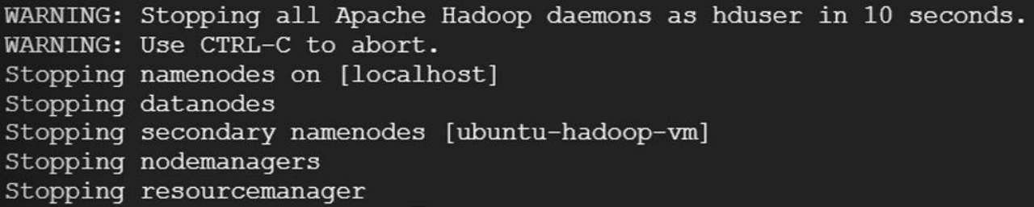

**Done**